**Gebze Technical University**

**Department of Computer Engineering**

**CSE344 - Spring 2024**

**Homework 5**

**AHMET ALPER UZUNTEPE**

**1901042669**

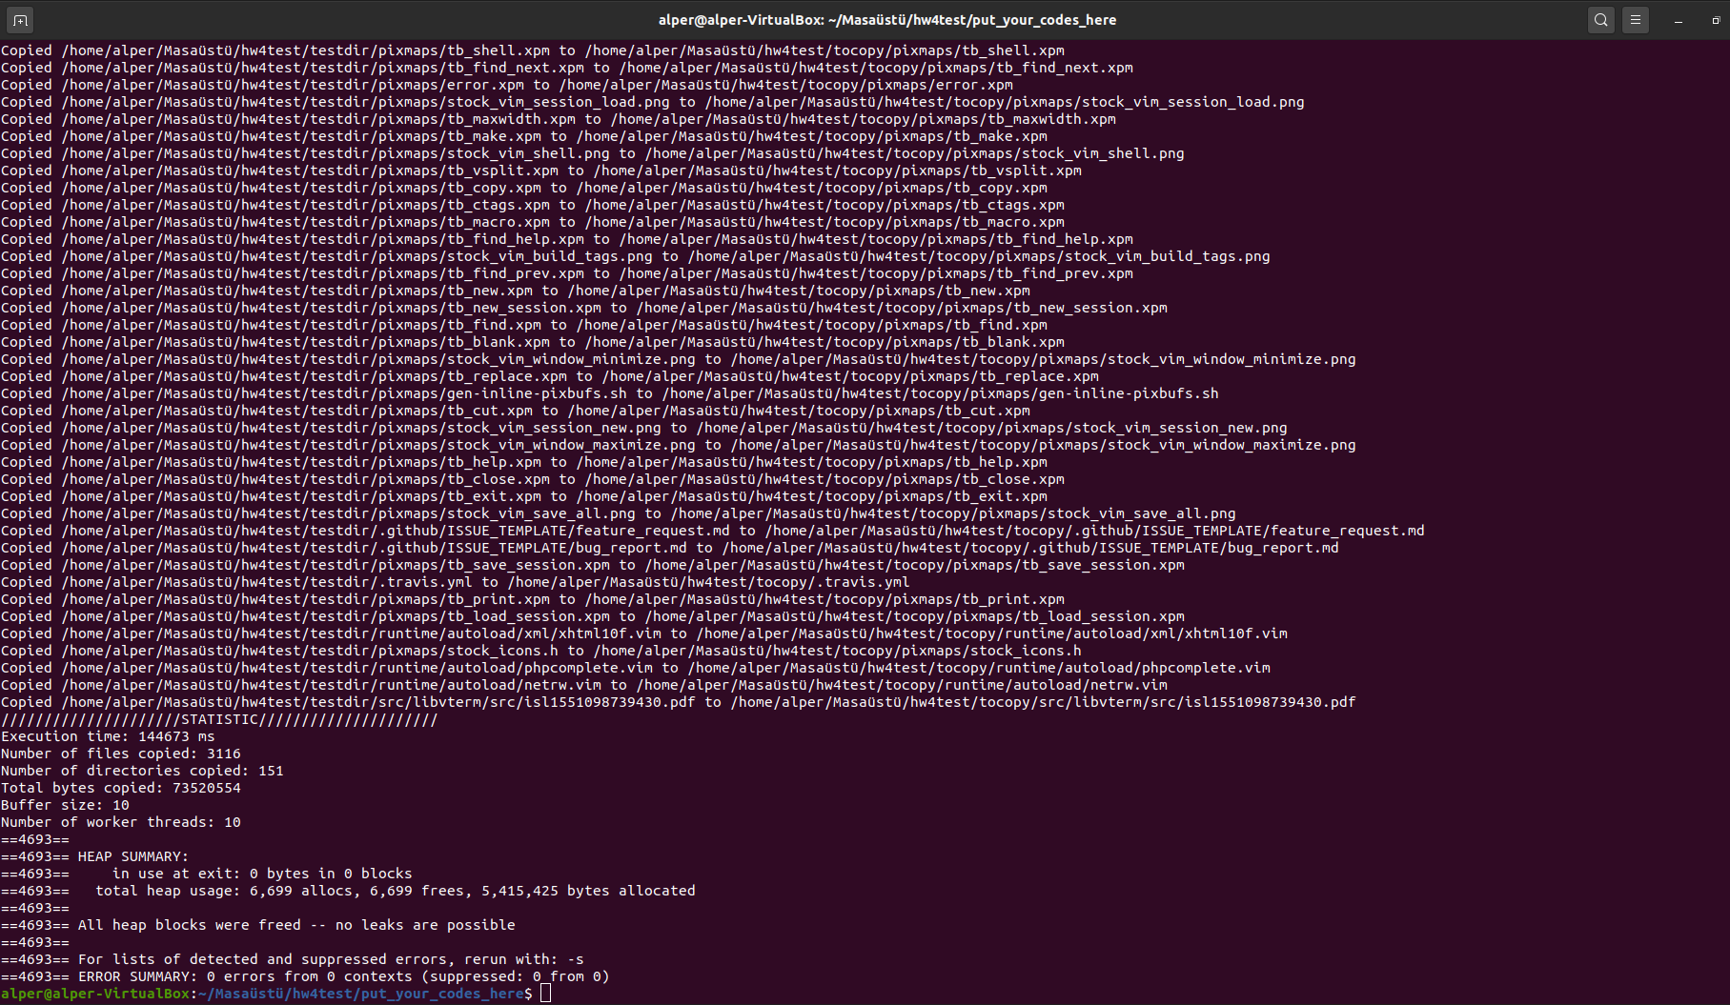

**I USED CONDITION VARIABLES AND BARRIER IN HW4 SO IT IS SAME WITH PREVIOUS HOMEWORK.**

**Overview**

I wrote this code for implementation and functionality of a multithreaded file copy program in C. The program leverages POSIX threads (pthreads) to manage concurrent file copying from a source directory to a destination directory. Key components of the program include the use of a circular buffer to manage file information, condition variables for synchronizing access to the buffer, and barriers for coordinating the start of worker threads.

**Initialization**

The program begins by initializing necessary data structures and variables. This includes parsing command-line arguments to set the buffer size, number of worker threads, and paths for the source and destination directories.

**Buffer Structure**

A circular buffer is used to hold information about files to be copied. The buffer is implemented using a structure buffer_t, which includes:

* An array buffer to store file information.
* Indices front and rear to manage the head and tail of the buffer.
* A count variable count to track the number of items in the buffer.
* Mutex mutex and condition variables cond_full and cond_empty for synchronization.

**Thread Functions**

The program employs two types of threads: a manager thread and multiple worker threads.

Manager Thread

The manager thread is responsible for:

* Reading directory contents.
* Enqueuing file information into the buffer.
* Handling directories recursively by creating corresponding directories in the destination.

The manager thread sets a flag done_flag upon completing directory processing, signaling to worker threads that no more files will be enqueued.

Worker Threads

Worker threads perform the following tasks:

* Wait at a barrier to ensure all threads start simultaneously.
* Dequeue file information from the buffer.
* Copy data from source to destination files using read and write operations.
* Signal completion and handle errors if encountered.

**Synchronization Mechanisms**

**Condition Variable Usage**

cond_full

* **Wait (Manager Thread):** 
* The manager thread waits on cond_full when it tries to add a file to a full buffer. This ensures that the manager thread blocks until there is space available in the buffer.
* The pthread_cond_wait function releases the mutex and waits for the cond_full condition variable to be signaled. Once signaled, it re-acquires the mutex and proceeds.
* **Signal (Worker Thread):**

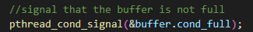

* Worker threads signal cond_full when they remove a file from the buffer, indicating that there is now space available for the manager to add new files.
* This function wakes up one of the threads waiting on the cond_full condition variable, allowing the manager thread to proceed and enqueue more files.

cond_empty

* **Wait (Worker Threads):**

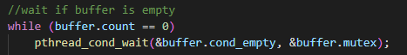

* Worker threads wait on cond_empty when they try to remove a file from an empty buffer. This ensures that worker threads block until there is a file available in the buffer.
* Similar to cond_full, pthread_cond_wait releases the mutex and waits for the cond_empty condition variable to be signaled. Once signaled, it re-acquires the mutex and proceeds.
* **Signal (Manager Thread):**

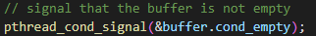

* The manager thread signals cond_empty when it adds a file to the buffer, indicating that there is now a file available for the workers to process.
* This function wakes up one of the threads waiting on the cond_empty condition variable, allowing a worker thread to proceed and dequeue a file.
* **Mutex** and **Condition Variables**: The condition variables work in conjunction with a mutex (buffer.mutex). This mutex ensures that only one thread can access the buffer at a time, preventing race conditions.
* **Blocking** and **Waking Up Threads**: The condition variables are used to block threads when the buffer is in an undesirable state (full or empty) and to wake up threads when the state changes to a desirable one (space available or file available).
* **Synchronization**: This mechanism allows the manager and worker threads to work efficiently together without busy-waiting, leading to better performance and resource utilization.

**Barrier Usage**

* Initialization:



* The barrier is initialized in the main function with a count of num_workers + 1, accounting for the manager thread and all worker threads.
* Start Synchronization:



* At the beginning of both manager and worker functions, threads wait at the barrier, ensuring they all start their operations together.
* End Synchronization:



* After processing the directory, the manager thread signals the completion of its task by waiting at the barrier, which is now only waited upon by the manager.
* This ensures that worker threads are aware that no more files will be added to the buffer once the manager has completed its task.
* Barrier Destruction:



* Finally, the barrier is destroyed in the main function after all threads have finished their execution.
* The barrier usage ensures proper synchronization between the manager and worker threads. The start barrier ensures that all threads begin processing simultaneously, while the end barrier ensures that worker threads are aware of the completion of directory processing by the manager. This coordination helps prevent race conditions and ensures efficient parallel processing of file copying tasks.

**CODE EXPLANATION**

* Structures and Global Variables
* **file_info_t** Structure holds information about each file to be copied.

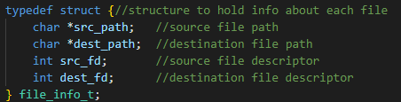

* **buffer_t** Structure represents a circular buffer used to store file_info_t items.

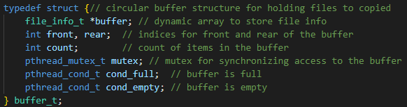

* Global Variables

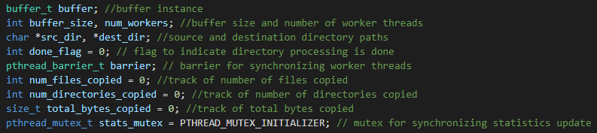

* **buffer**: An instance of buffer_t used to hold file information during the copying process.
* **buffer_size**: An integer indicating the maximum size of the buffer.
* **num_workers**: An integer indicating the number of worker threads.
* **src_dir**: A pointer to a string representing the source directory path.
* **dest_dir**: A pointer to a string representing the destination directory path.
* **done_flag**: An integer flag used to indicate when the manager thread has finished processing the directory.
* **barrier**: A pthread barrier used to synchronize the start of the worker threads.
* **num_files_copied,num_directories_copied,total_bytes_copied**: They are using for tracking and calculating STATISTICS.
* **stats_mutex** :A Mutex for synchronizing statistic updates.
* Buffer Initialization

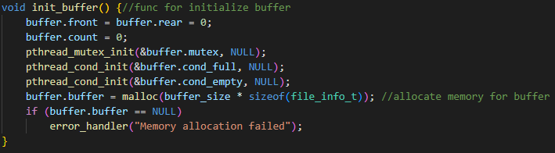

This function initializes the circular buffer, setting the front and rear indices to 0 and the count to 0. It also initializes the mutex and condition variables.

* free_file_info Function

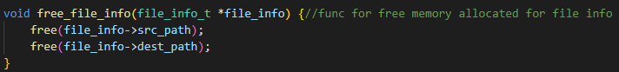

free_file_info function is designed to release memory that was dynamically allocated for the file paths within a file_info_t structure. This is necessary to avoid memory leaks, which occur when dynamically allocated memory is not properly deallocated.

* Enqueue Function

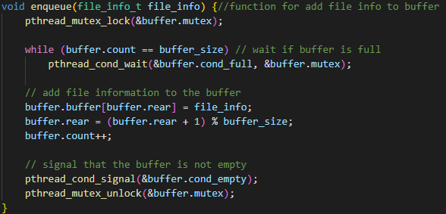

The enqueue function adds file information to the buffer. If the buffer is full, the function waits until a slot becomes available. After enqueuing, it signals that the buffer is not empty.

* Dequeue Function

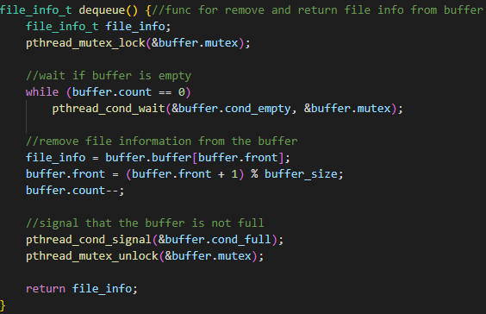

The dequeue function removes and returns file information from the buffer. If the buffer is empty, the function waits until an item is available. After dequeuing, it signals that the buffer is not full.

* Manager Thread Function

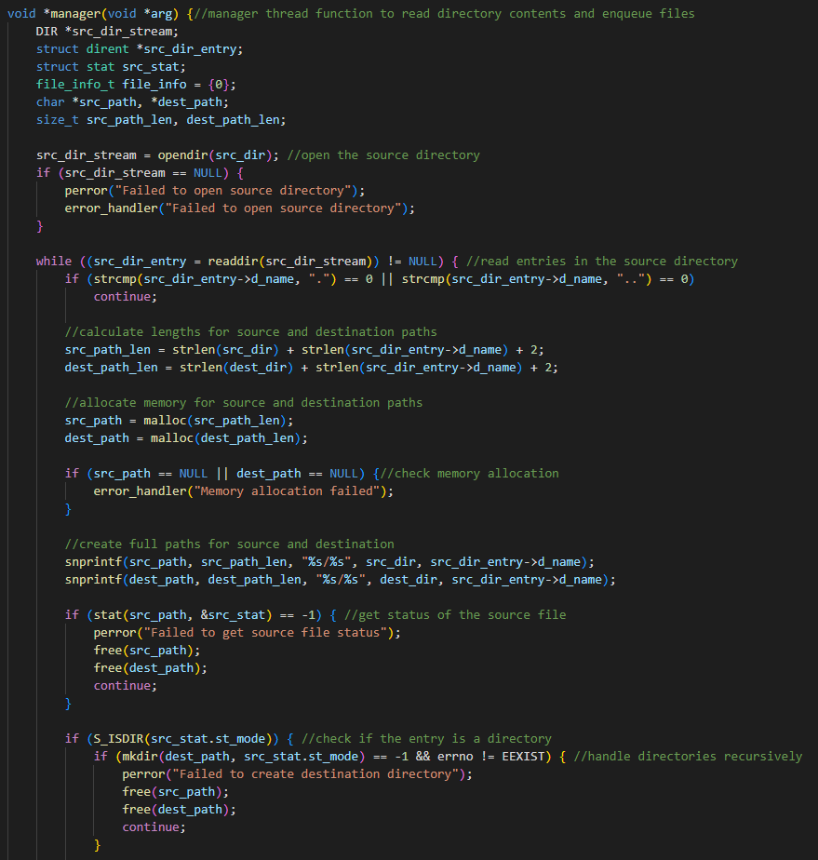

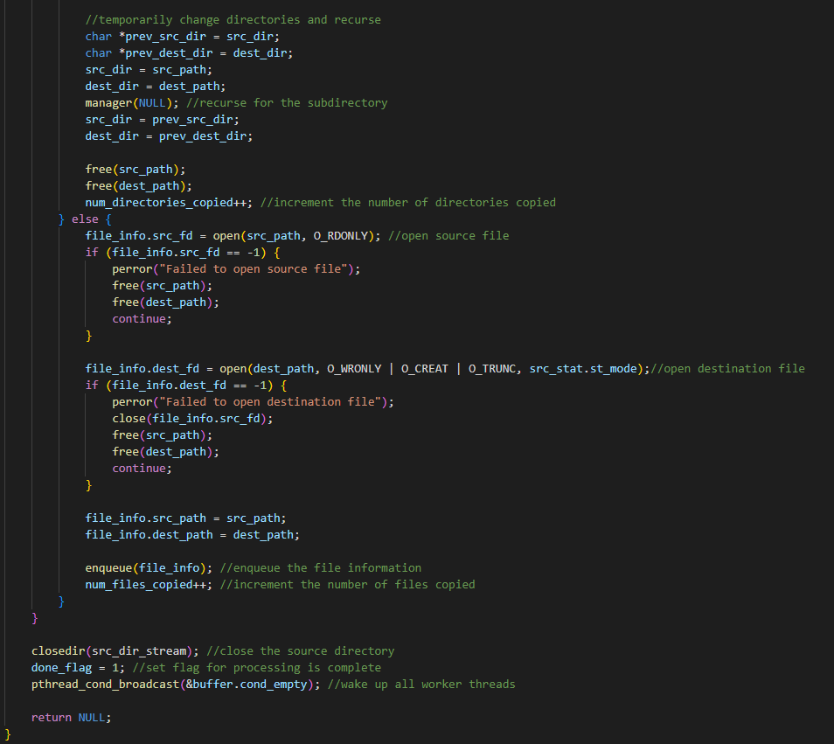

The manager function opens the source directory and iterates through its contents. For each file, it creates the corresponding destination path and enqueues the file information. If a directory is encountered, it handles it recursively.

* Worker Thread Function

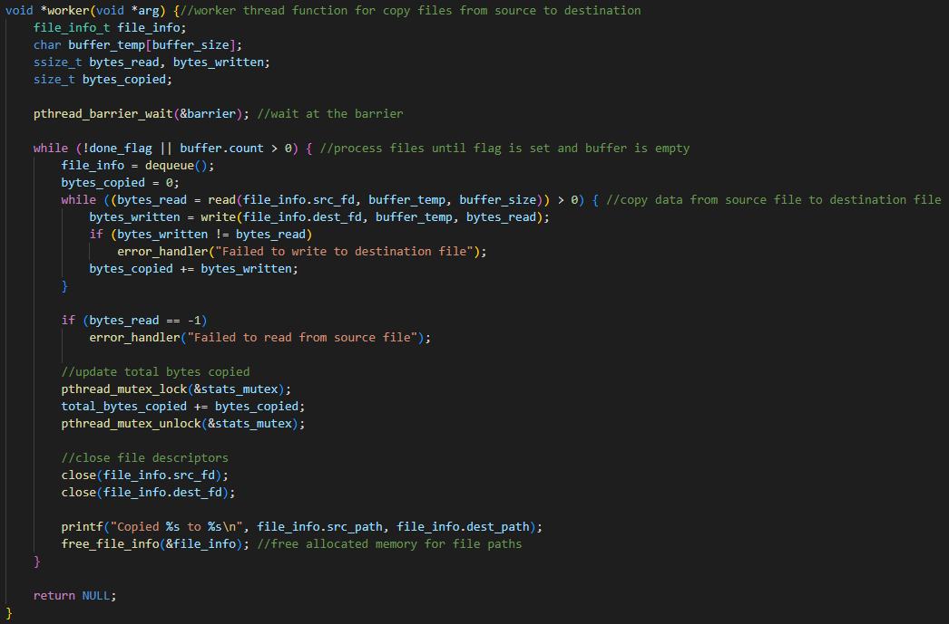

The worker function waits at the barrier to synchronize with other threads. It then enters a loop where it dequeues file information and performs the file copy operation. The loop continues until all files are processed and the buffer is empty.

* Main Function

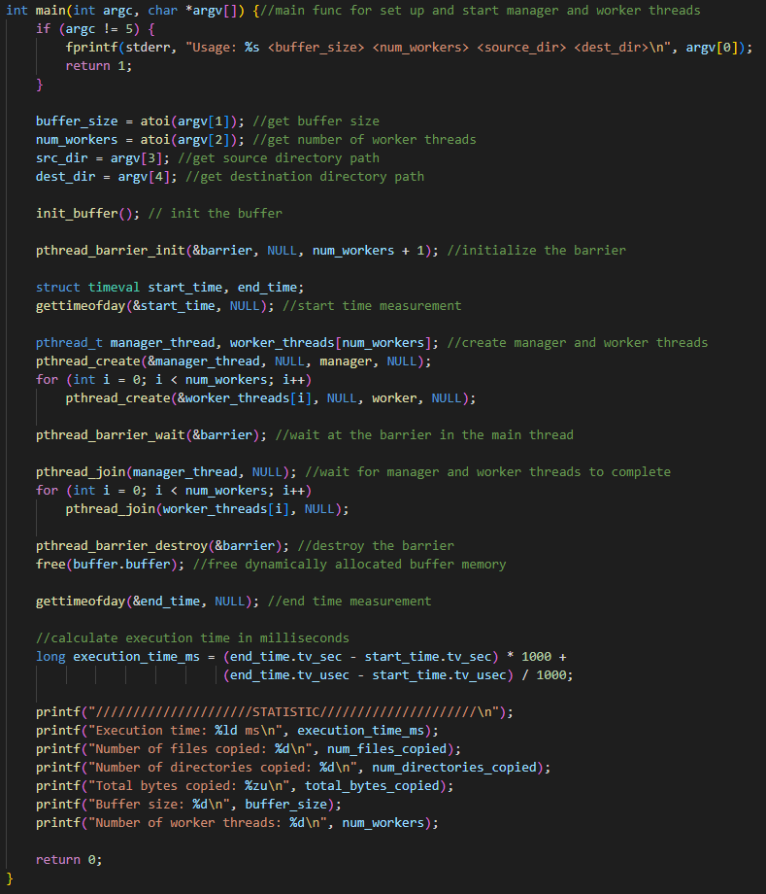

The main function initializes the buffer, barrier, and creates the manager and worker threads. It then waits for all threads to complete their tasks before exiting. At the end it prints the STATICS .

**OUTPUT**

1. **valgrind ./MWCp 10 10 ../testdir/src/libvterm ../tocopy**

**(THERE IS NO MEMORY LEAK)**

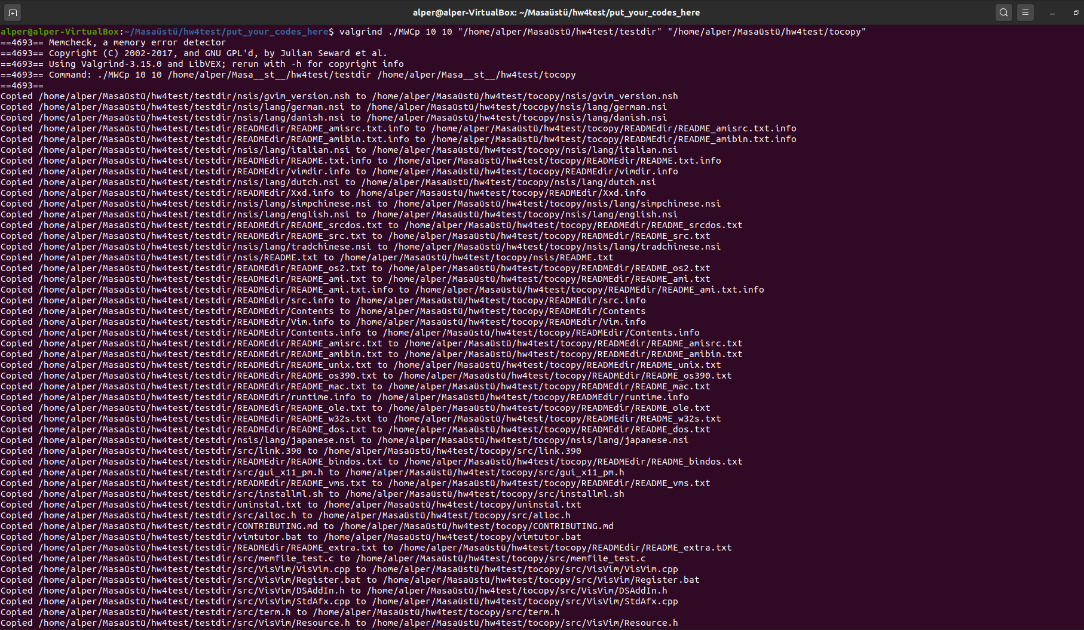



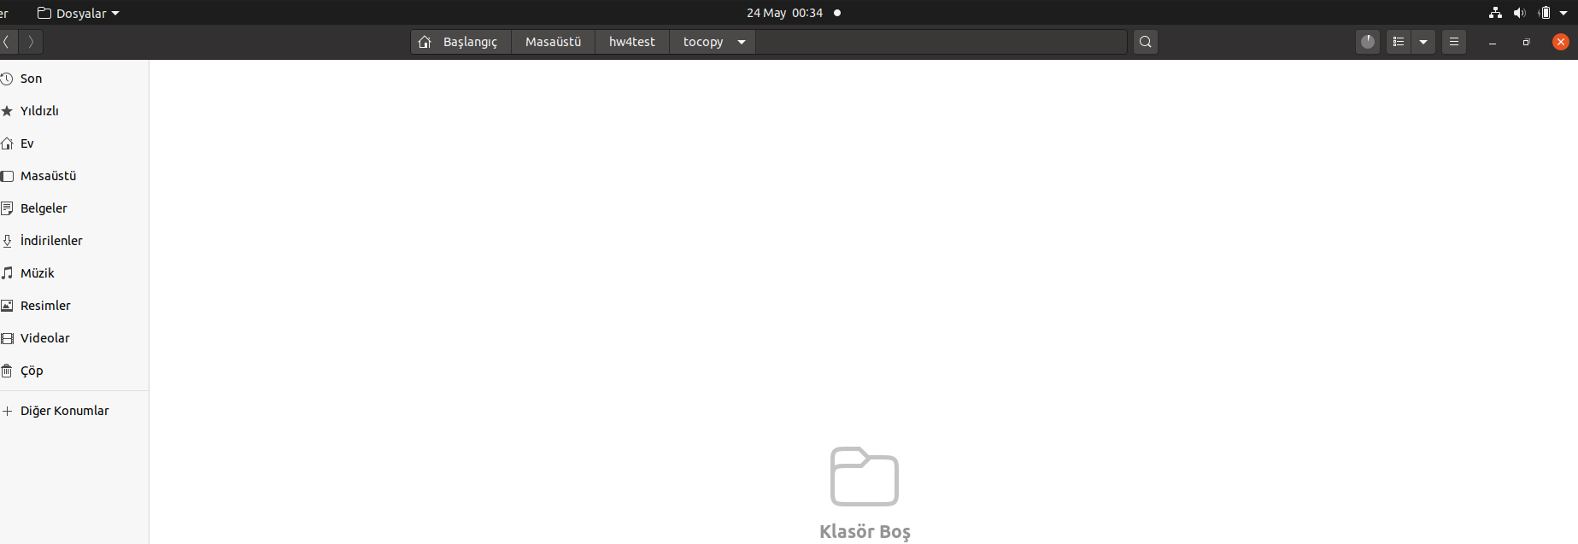

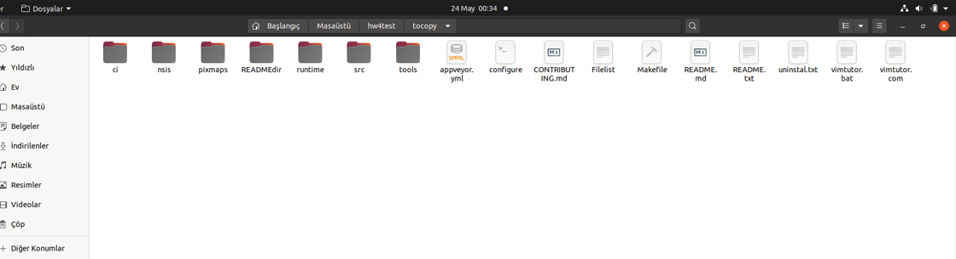

1. **/MWCp 10 4 ../testdir/src/ libvterm/src ../toCopy**

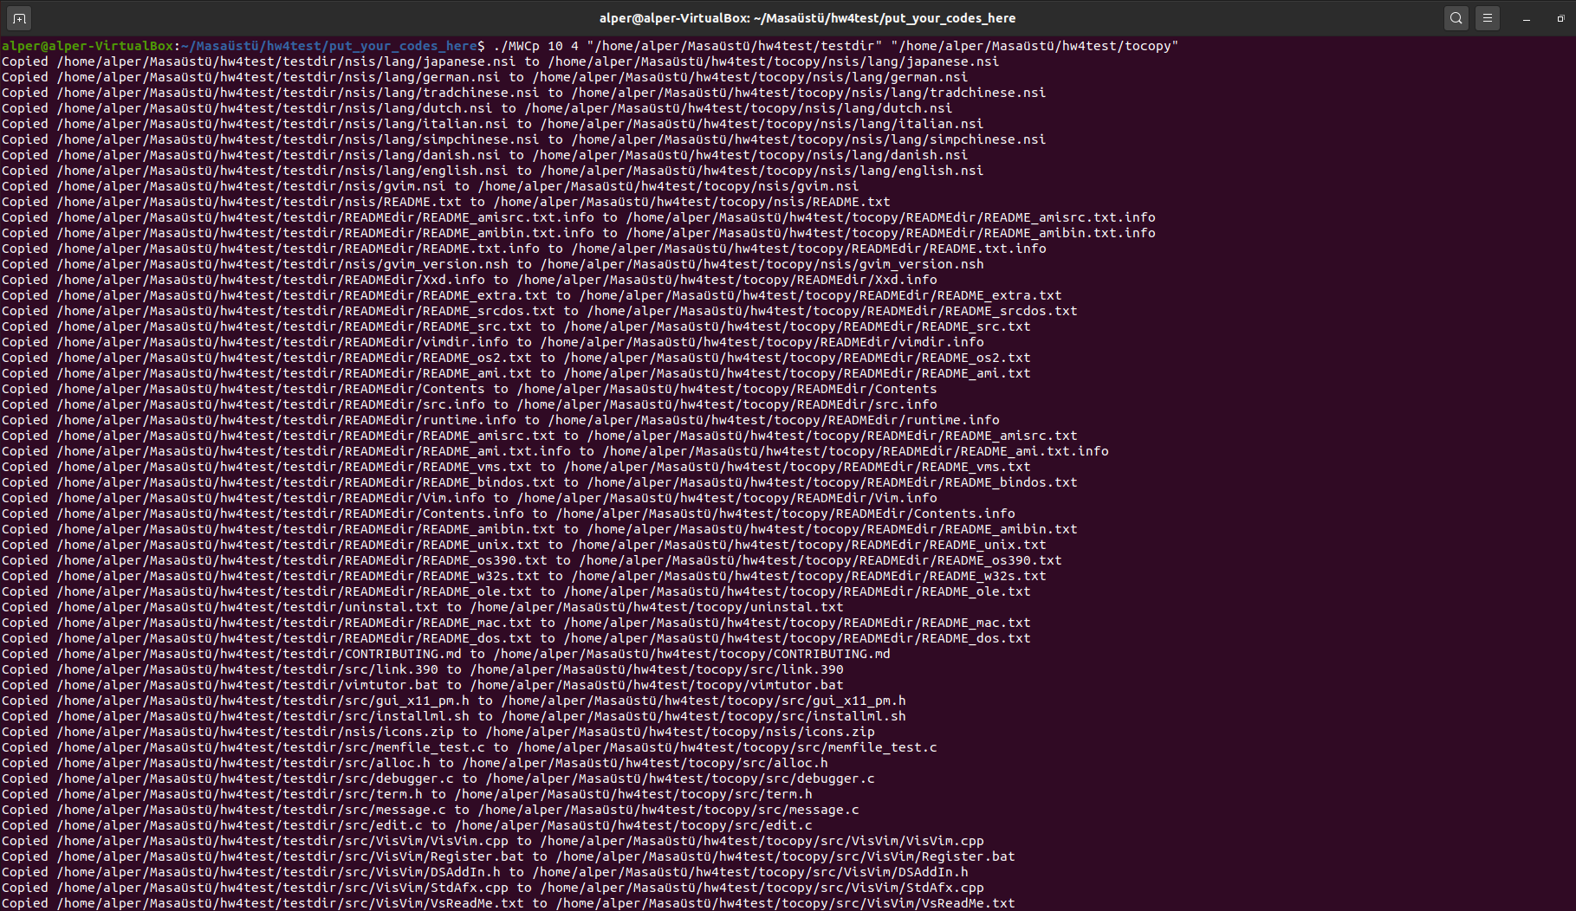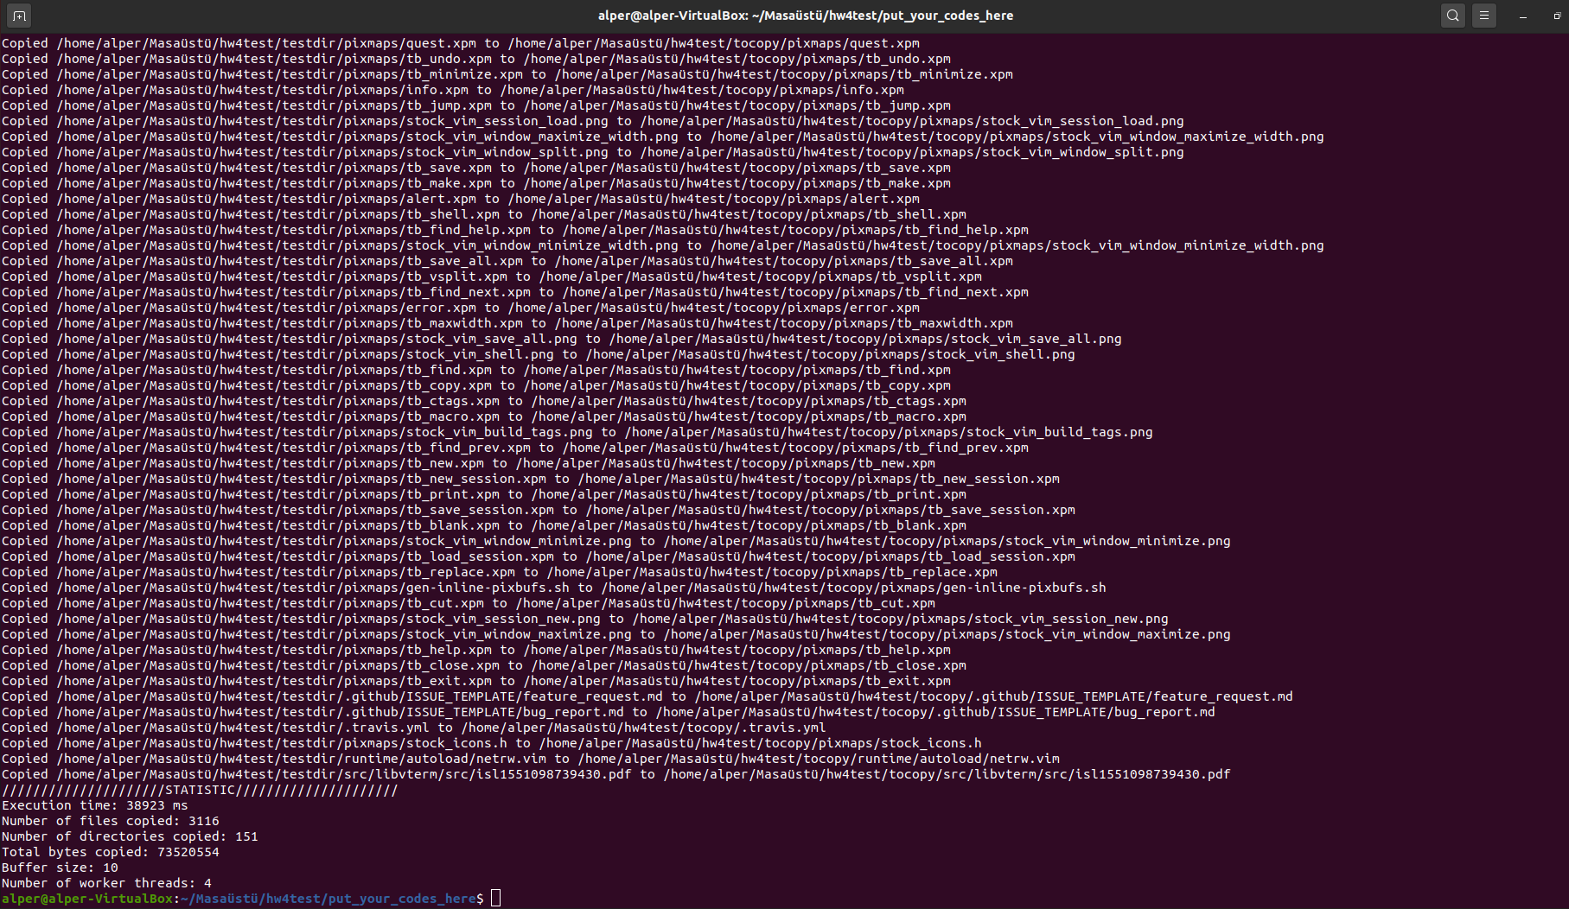

1. **./MWCp 10 10 ../testdir/src/ libvterm/src ../toCopy**

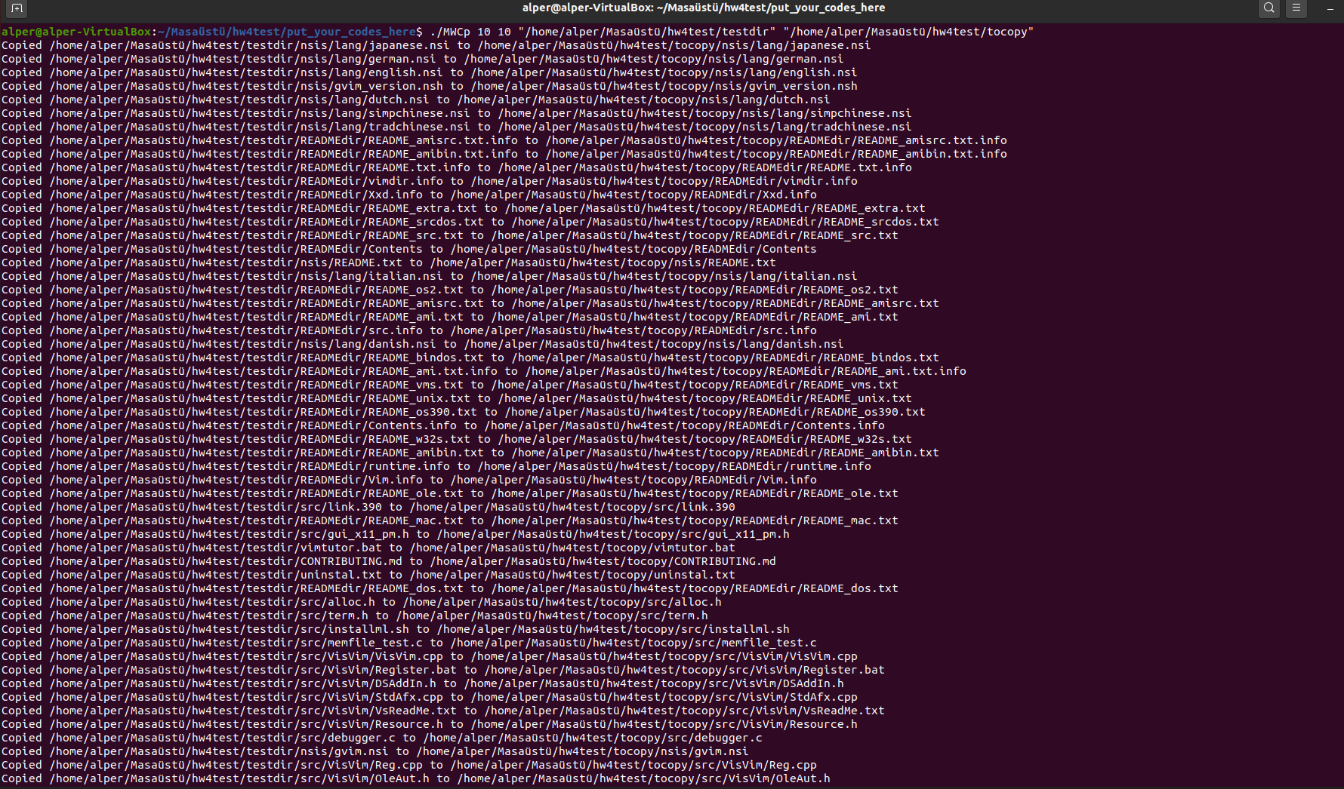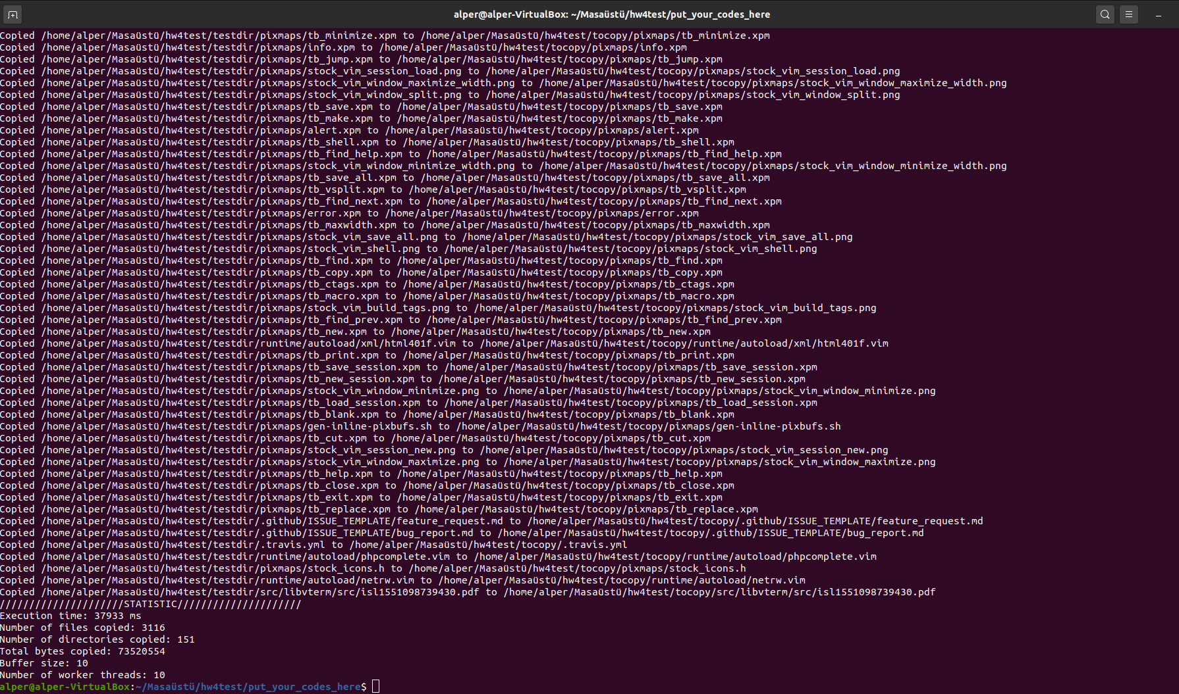

1. **./MWCp 100 4 ../testdir/src/ libvterm/src ../toCopy**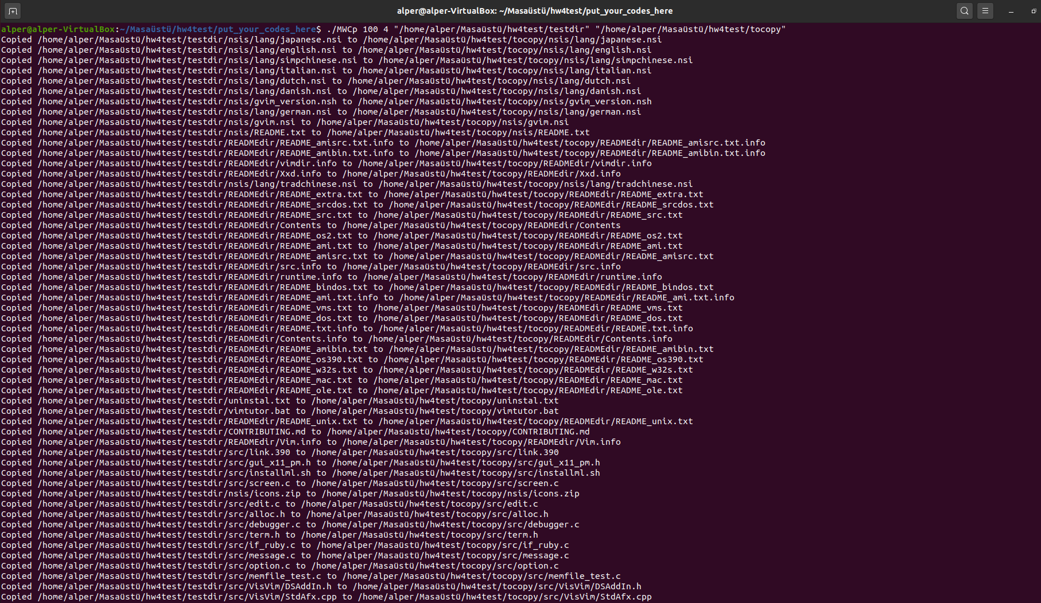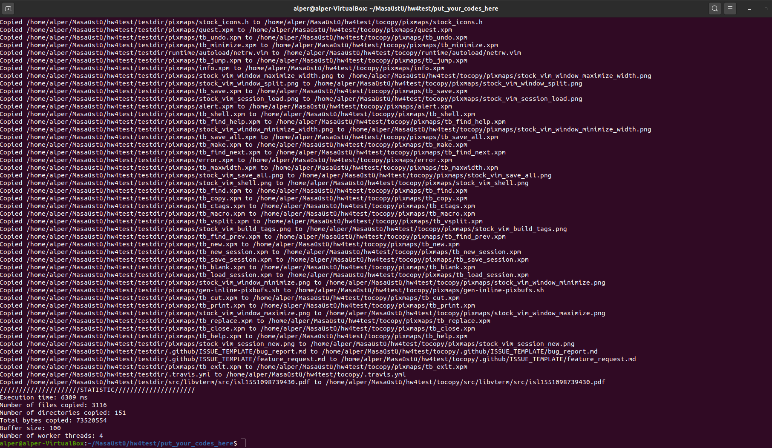

**FILE**

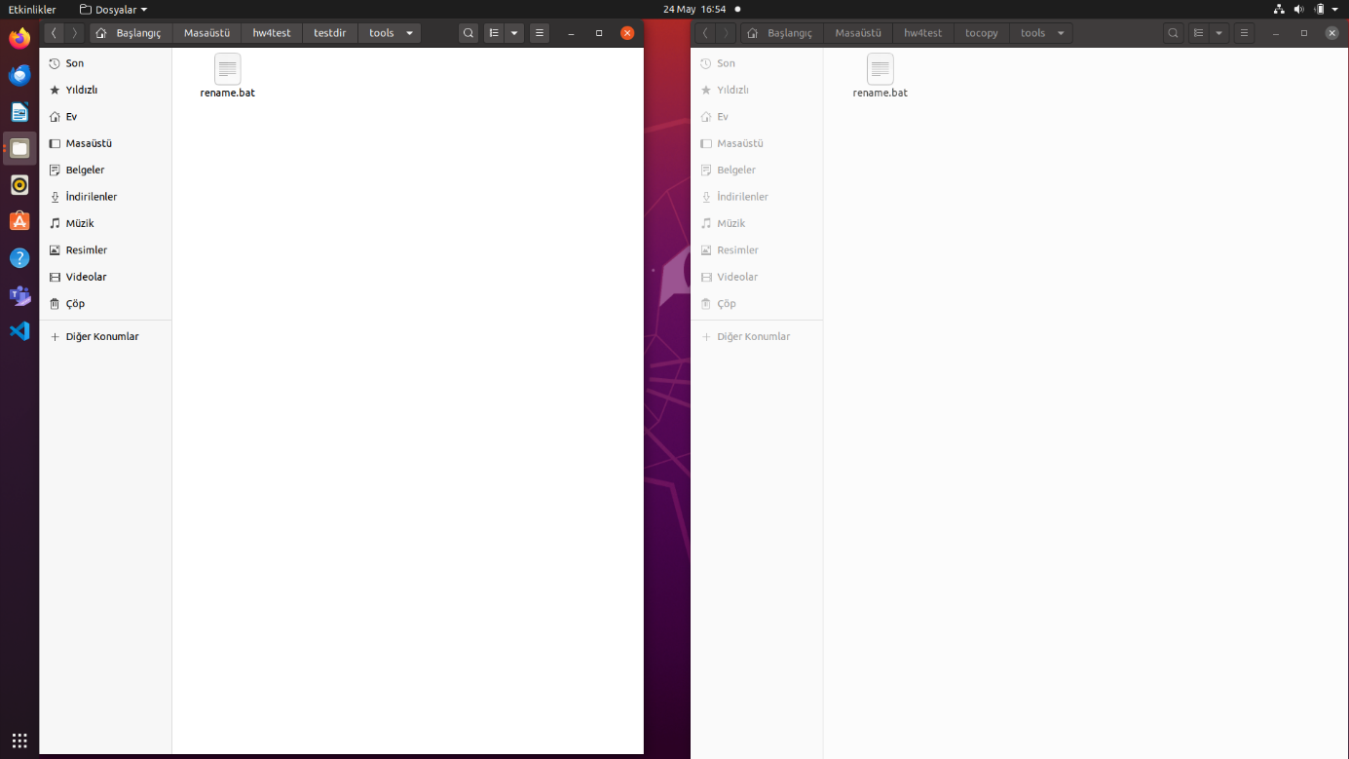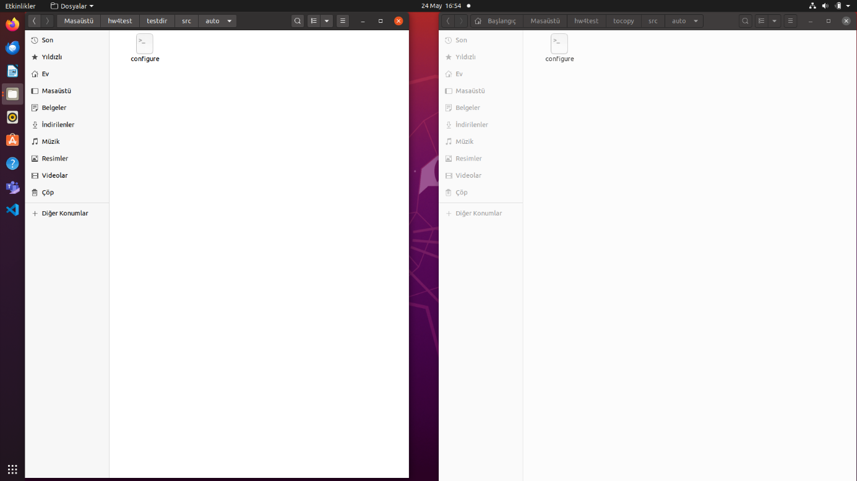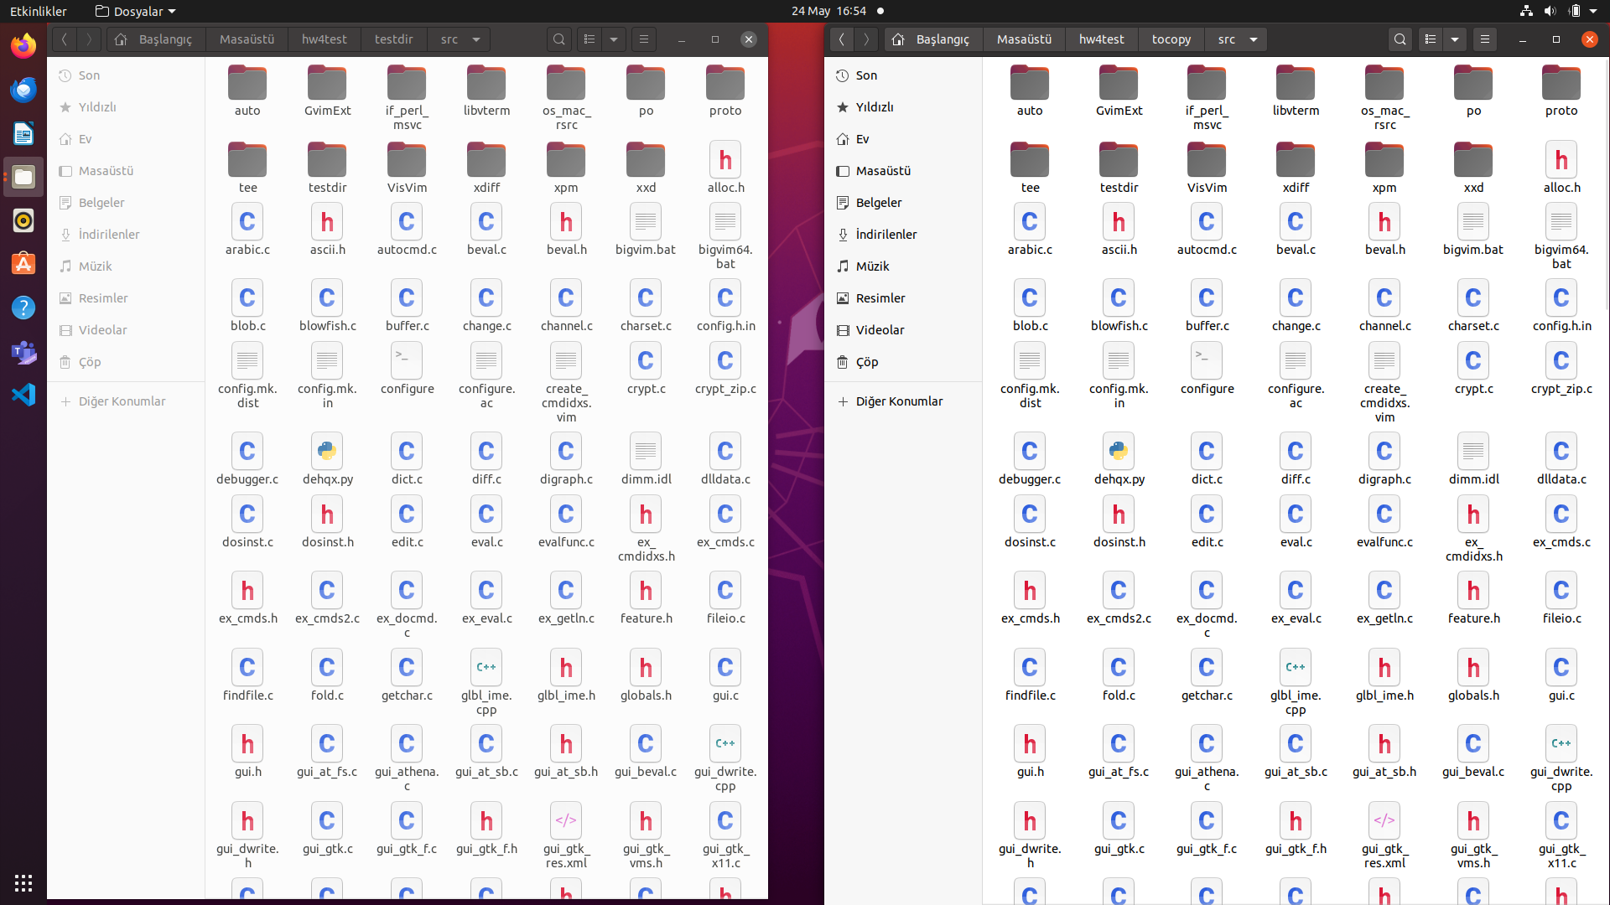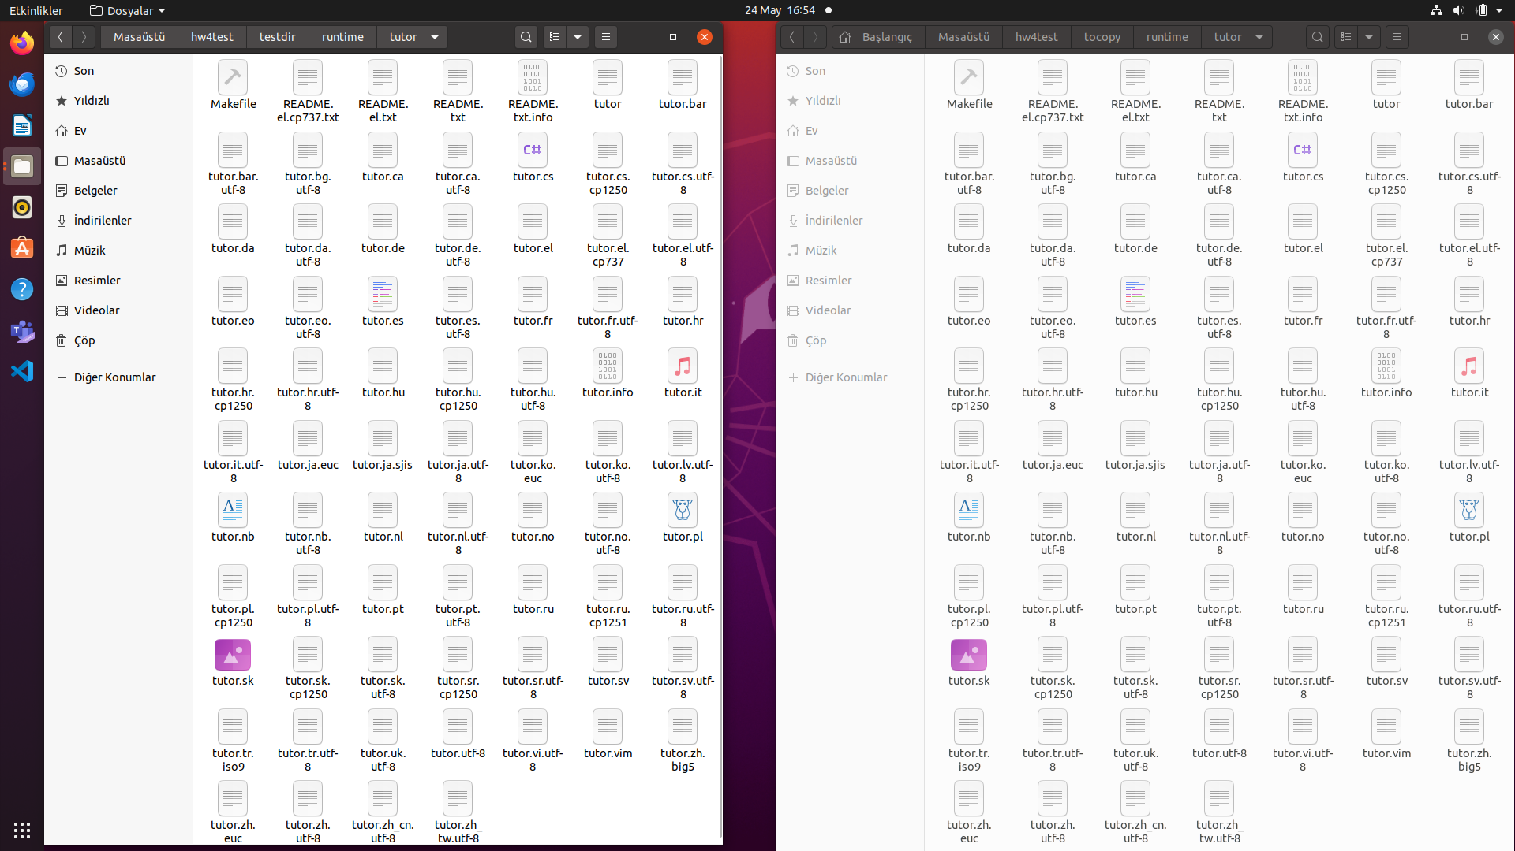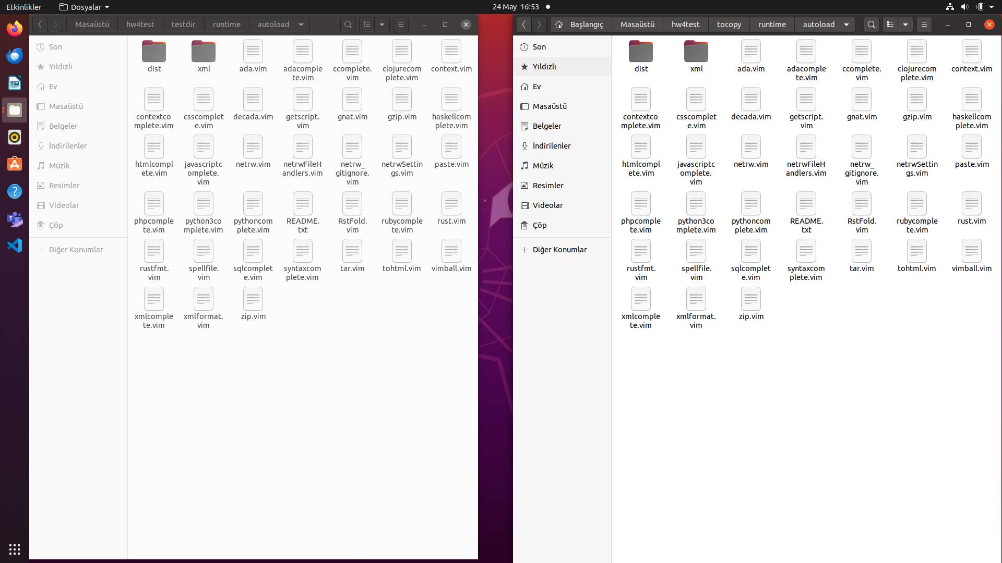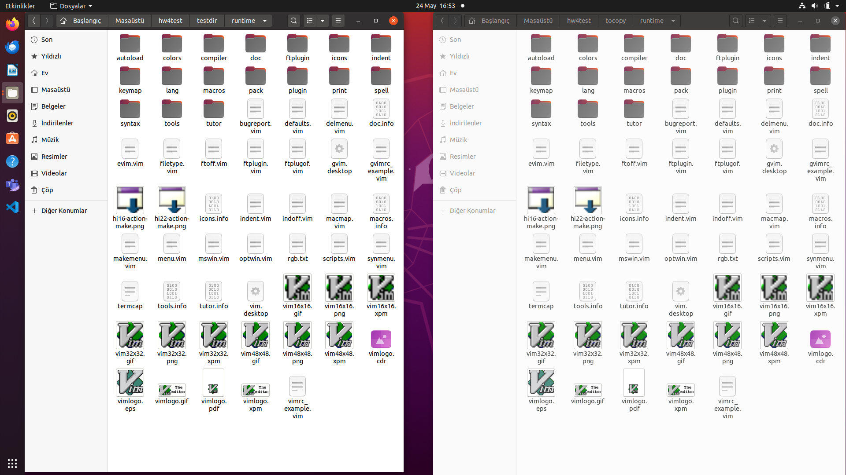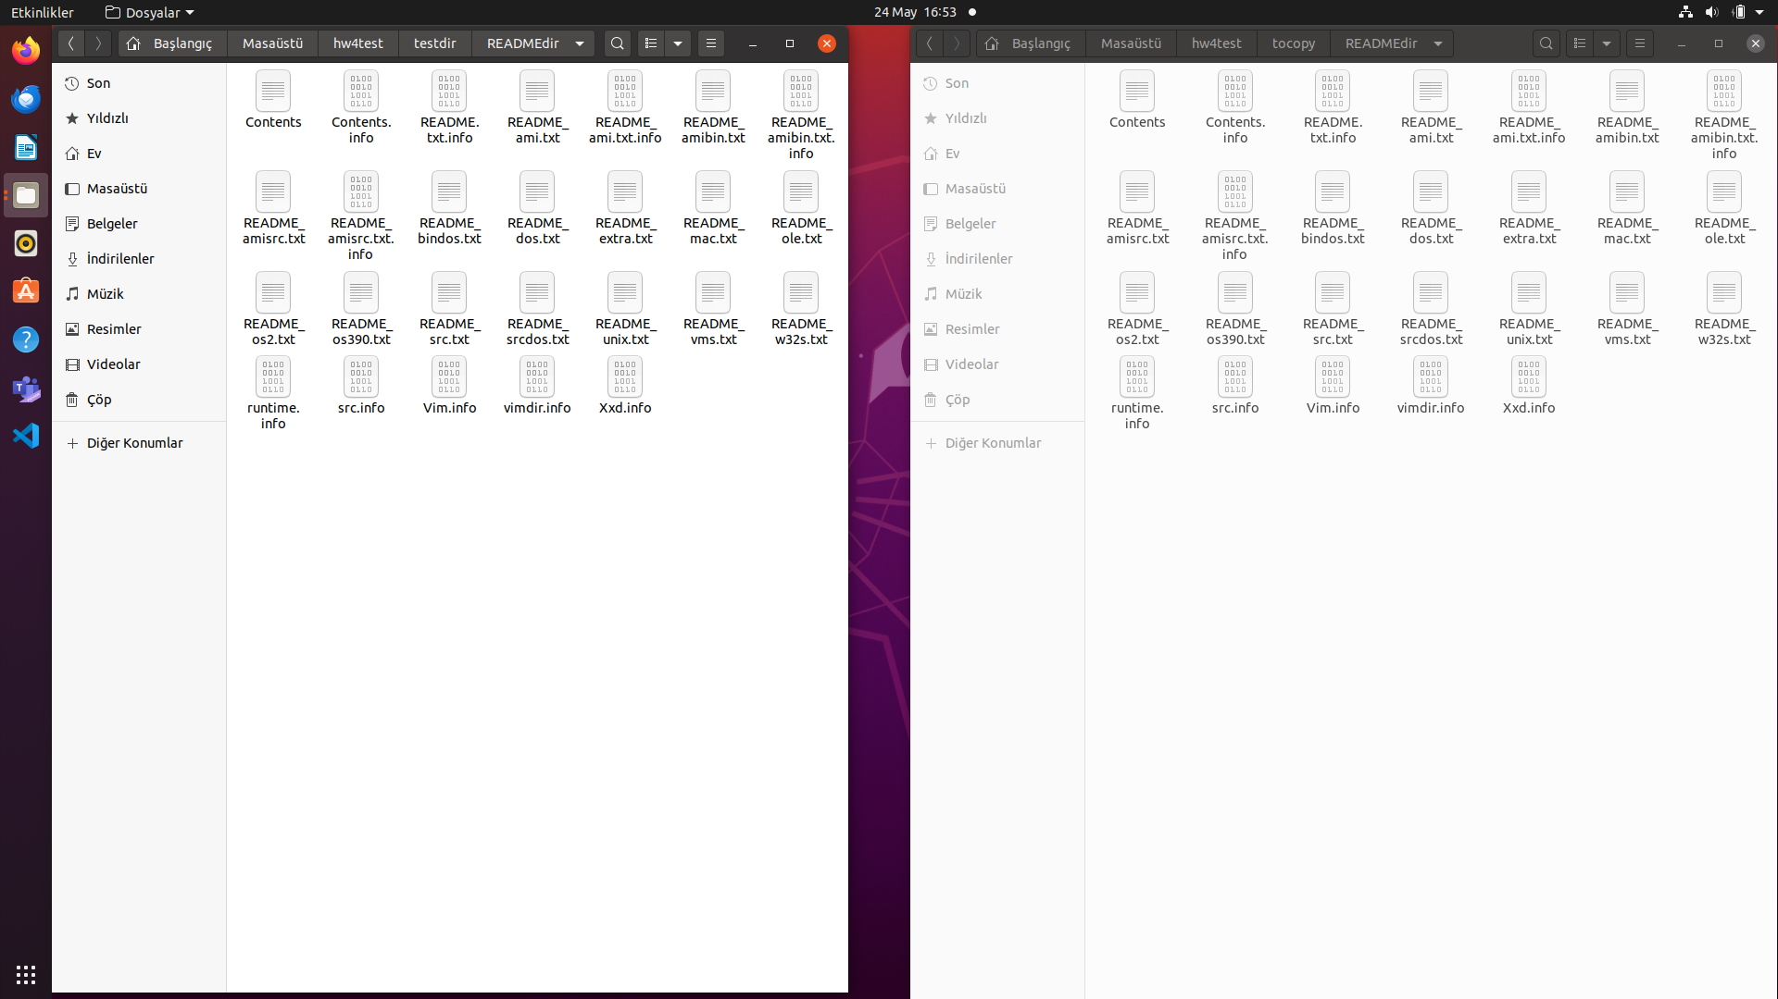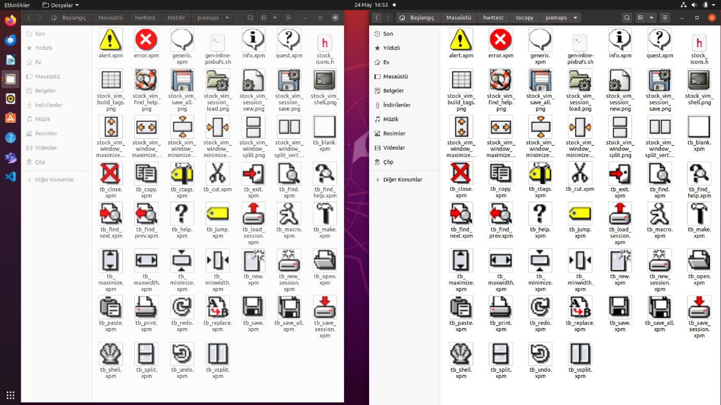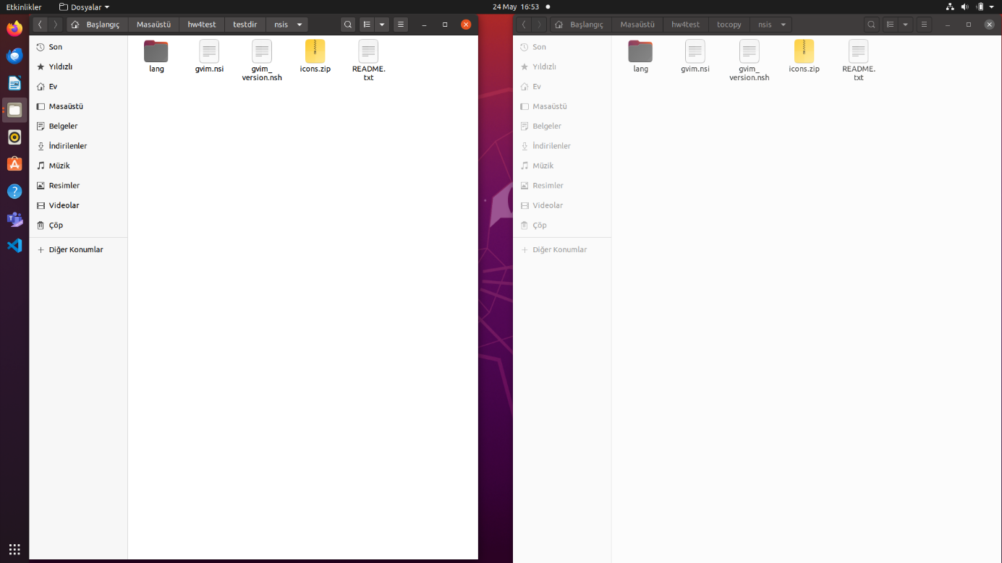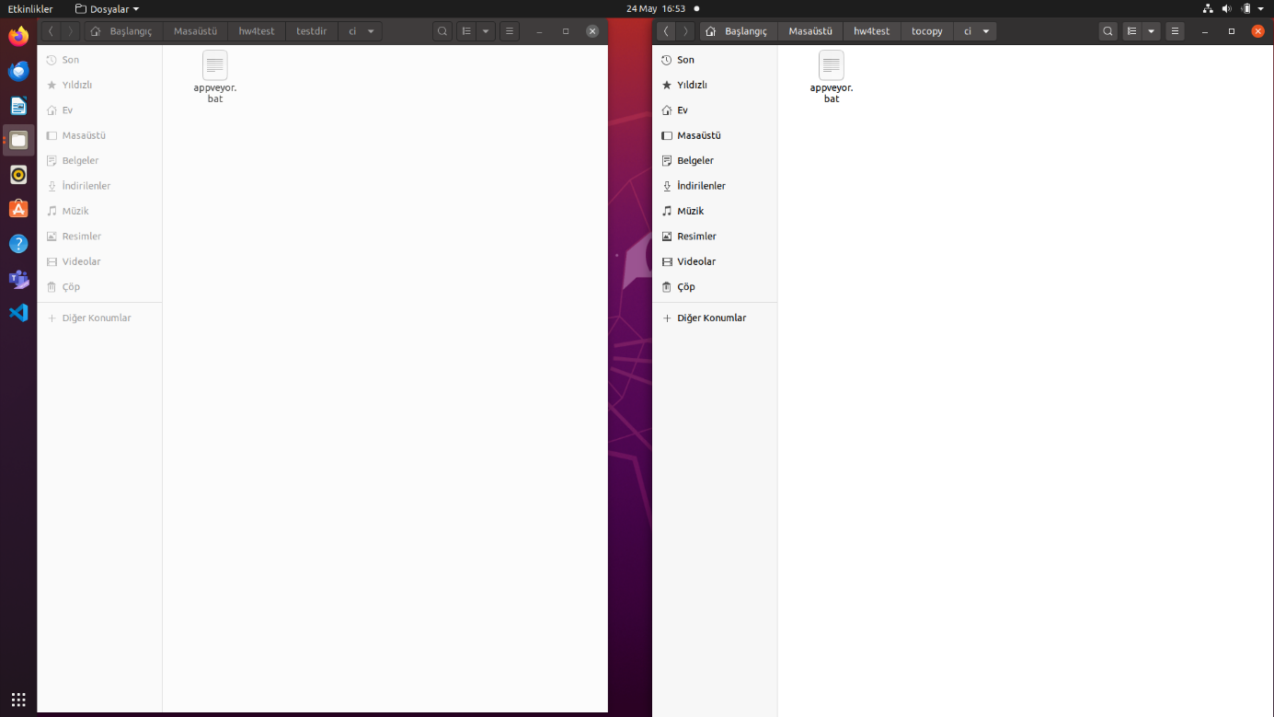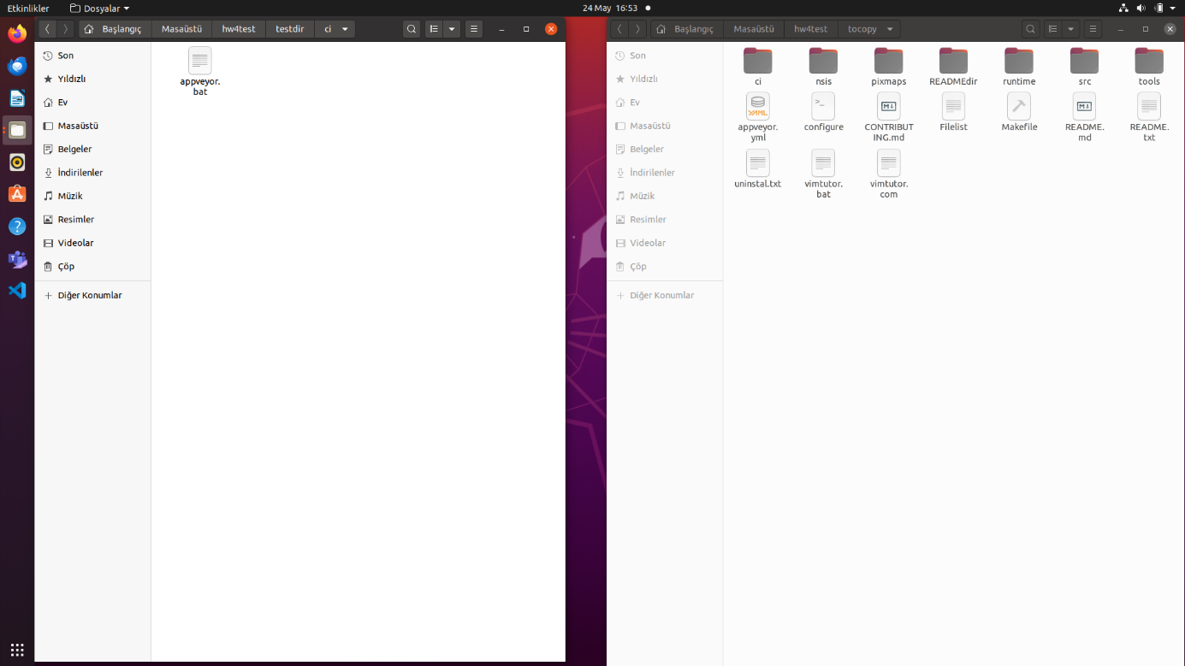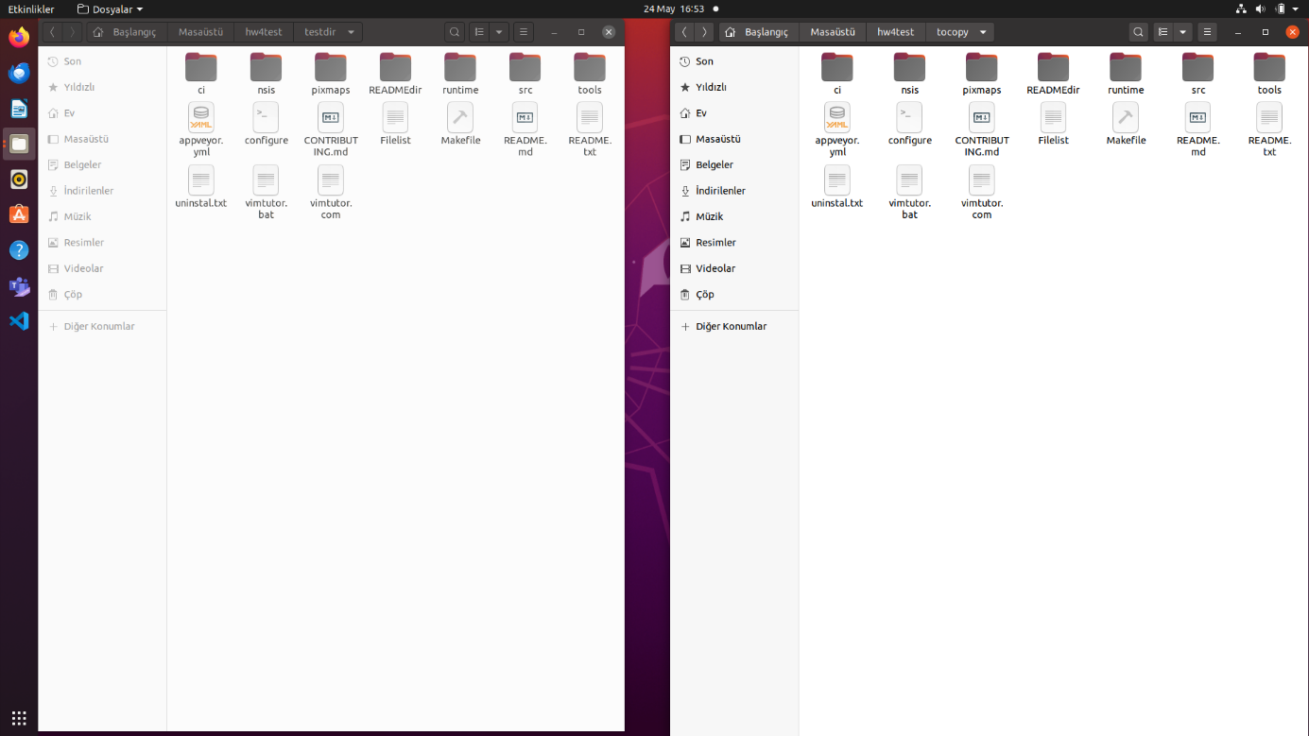

**MAKEFILE**



